Digital Egypt Builders Initiative
Final Project

Meow Platform

Presented by:
Student ID Student Name
21026802 Hadeer Mahmoud
21053499 Alaa Ahmed Saad
21093960 Retaj Ashraf
21038360 Hasnaa Mohammed
21080058 Mariam Ashraf

Eng. Mohammed Hamed

December 2025

Table of Contents

Table of Figures iii
Declaration & Acknowledgement v
Abstract 1
1. Introduction 2
2. Literature Review 3
3. Methods and Materials 4
3. Methods and Materials 5
4. Implementation 6
4. Implementation 7
5. Research Results and Discussions & Conclusions and Future Work 8
References 9
References 10

Table of Figures

Figure1 1 2
Figure1 2 5
Figure1 3 6
Figure1 4 7
Figure1 5 7

Declaration
"I, the undersigned, hereby declare that this Final Project, titled: Meow Platform: An Integrated Platform for Pet Owners, is my original and independent work.
I further declare that:
- This project, either in whole or in part, has not been submitted previously for any academic degree or certification at this or any other educational institution.
- All sources and materials used in this project have been accurately and clearly acknowledged and referenced in the References section, in accordance with the requirements of academic integrity.
- I assume full responsibility for any shortcomings or errors that may be found in this work."

Acknowledgement
"I extend my sincere gratitude and appreciation to the Digital Egypt Builders Initiative (DEBI) and the Ministry of Communications and Information Technology for providing this invaluable educational opportunity, which has significantly contributed to refining my technical and practical skills.
I also express my deepest thanks and respect to Eng. Mohammed Hamed, the project supervisor, for his precise scientific guidance and constructive advice, which were instrumental in achieving the required quality of this work.

Abstract
This project introduces Meow Platform, a comprehensive web platform designed to support cat lovers. The platform addresses the need for centralized, reliable information and a supportive community. It is composed of three integrated components: a Community Forum for social interaction; a RAG (Retrieval-Augmented Generation) Chatbot for expert advice based on specialized veterinary documents; and a Web Scraper to gather real-time data on veterinary clinics from external sources. Built using Python Flask, LangChain, and PostgreSQL, this system provides a holistic solution for feline care enthusiasts.
Keywords: Cat Care, Community Platform, RAG Chatbot, Web Scraping, Flask, LangChain

Introduction
The Meow platform aims to establish a central hub where cat enthusiasts can share stories, seek expert advice, and build a supportive community around feline care. The project is justified by the fragmented nature of pet care resources currently available. This platform unifies interaction, knowledge retrieval, and real-world service location into one user-friendly interface.
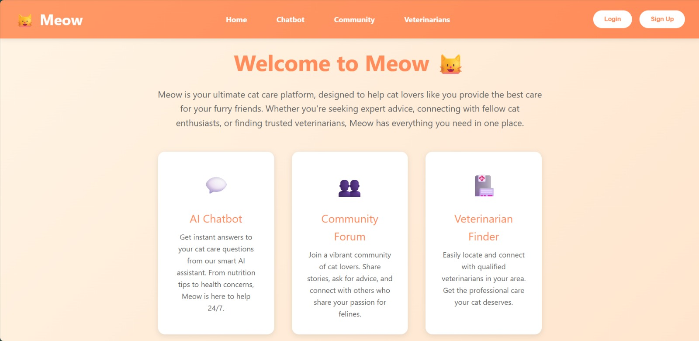
Figure1 1

Literature Review

This project draws upon established literature in web development, information retrieval, and data automation.
- Background: The project leverages Python Flask for a flexible web backend and PostgreSQL for scalable relational data management. The Chatbot utilizes Retrieval-Augmented Generation (RAG), which has been proven effective in grounding Large Language Model (LLM) outputs in a specific knowledge base (e.g., veterinary toxicology documents).
- Related Work: The project utilizes LangChain for orchestrating the RAG pipeline, including text splitting, embedding creation (using the Hugging Face's all-MiniLM-L6-v2 model), and fast vector search via FAISS. For data gathering, the use of Selenium/WebDriver for controlled, automated interaction with dynamic web pages (like Google Maps) is a standard methodology in web scraping.

Methods and Materials
3.1 Overall Tech Stack
Component |  | Technology | Role
Backend |  | Python 3, Flask, Flask-SQLAlchemy | Web server, logic, and database management.
Frontend |  | HTML5, CSS3, Vanilla JavaScript | User interface and responsive design.
AI/RAG |  | LangChain, FAISS, Hugging Face Embeddings | Information retrieval and AI response generation.
Database |  | PostgreSQL | Primary relational database.
DevOps |  | Docker, Docker Compose | Containerization and orchestration.

3.2 Data Gathering Methodology (Veterinary Clinics Scraper)
The scraper module automates the extraction of veterinary clinic data from Google Maps to ensure accurate, real-world information.
- Process: A Chrome WebDriver instance is initialized with custom configurations. A location-specific query (e.g., "veterinary clinics in Cairo") is executed. The scraper implements a dynamic scrolling mechanism to load all available results from the maps interface.
- Data Fields Extracted: Clinic Name, Rating, Number of Reviews, Address, Phone Number, Business Hours, and Website Link.
- Reliability: The module includes robust error handling for network delays and gracefully handles partial or invalid clinic entries before returning a structured list of verified data.
3.3 RAG Knowledge Base Setup (Chatbot)
The Chatbot's knowledge base ensures specialized advice.
- Data Preparation: Specialized documents (e.g., "VETERINARY TOXICOLOGY AND PHARMACY.pdf") are loaded, split into manageable text chunks, and processed.
- Vectorization and Indexing: The chunks are converted into numerical vectors using a Hugging Face embedding model, and an FAISS index is created for fast similarity search during query time. This forms the RAG knowledge source.
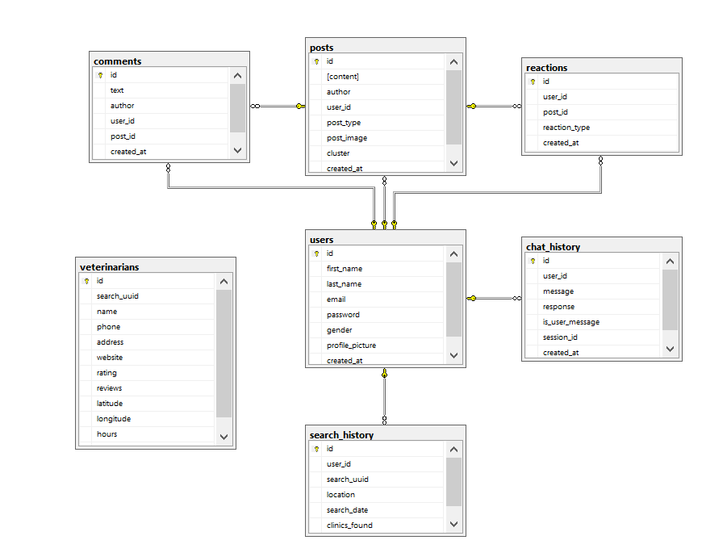
Figure1 2

Implementation
- 4.1 Meow Platform
The core platform is built with a Flask backend (app.py) and a clean HTML frontend (platform.html).
- Authentication: Features secure registration (with email verification), password hashing, and session management.
- Community Forum: Users can create and share posts, which are displayed in reverse chronological order. It supports post reactions (likes) and a nested commenting system. Authentication is required to post.

- 4.2 Meow - Cat Assistant Chatbot
The chatbot is integrated with the platform (or run as a separate component via app.ipynb).
- Functionality: It receives user queries and performs a RAG process—retrieving relevant knowledge snippets from the FAISS index and passing them to an LLM (e.g., GPT-4o-mini) to generate a grounded response.
- Key Features: RAG-based Q&A, automatic Multi-language Support (English and Arabic), and maintenance of Chat History using SQLite for contextual conversations.
- Frontend: A user-friendly, cat-themed interface (index.html) displays the chat history in bubbles.

- 4.3 Veterinary Clinics Scraper Module
This module runs independently to populate a database or provide real-time clinic search. The implementation ensures that all steps (browser initialization, search execution, dynamic scrolling, data extraction, and safe browser shutdown) are handled programmatically and reliably.

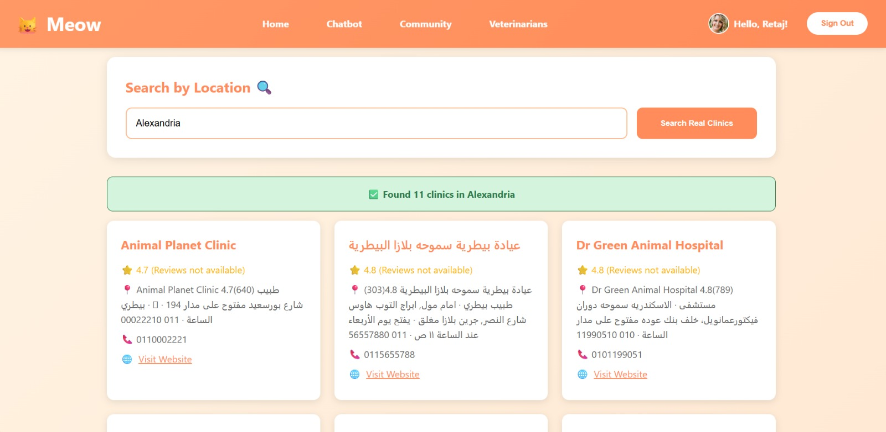
Figure1 3

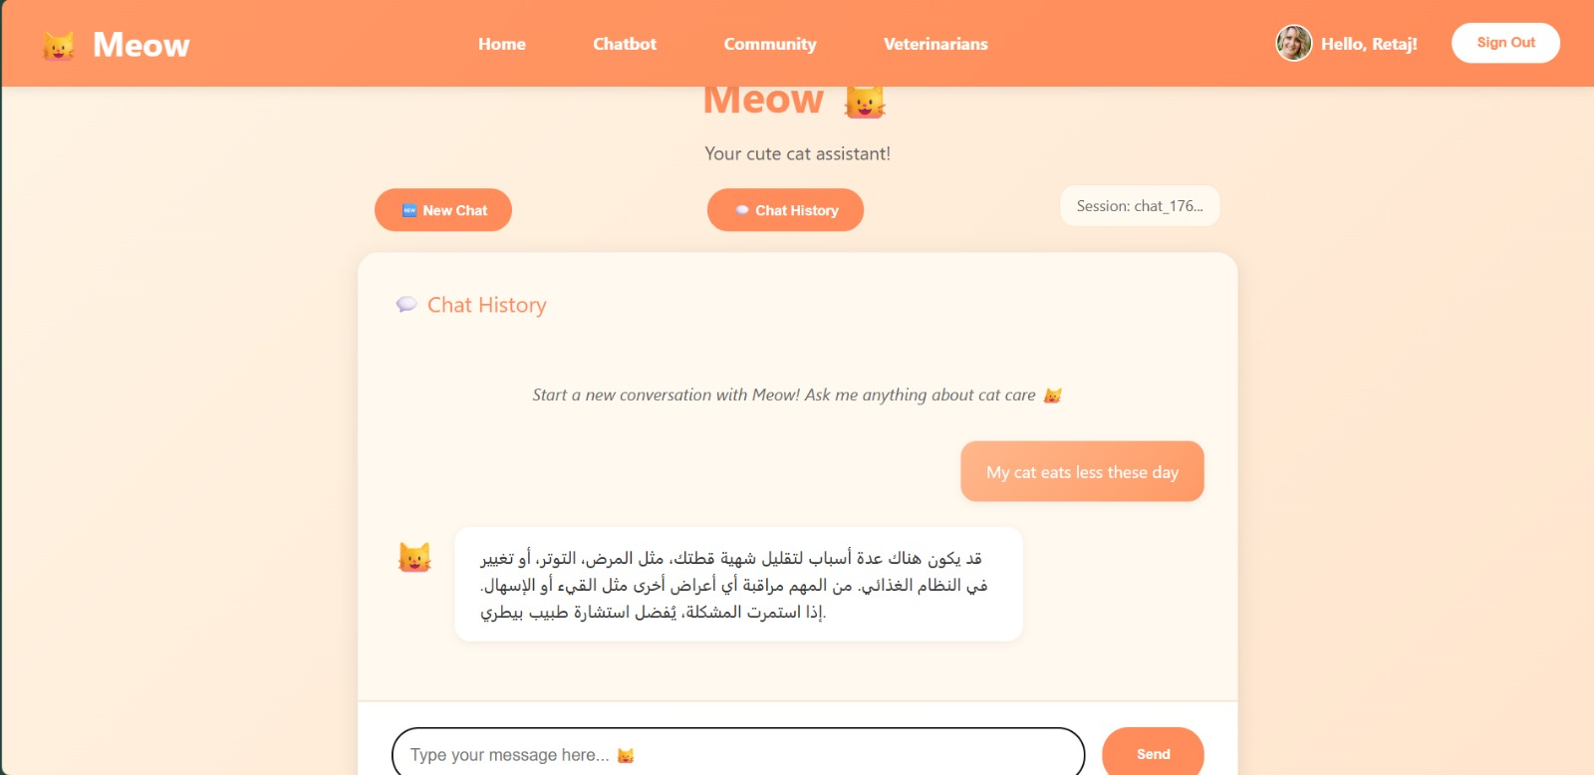
Figure1 4

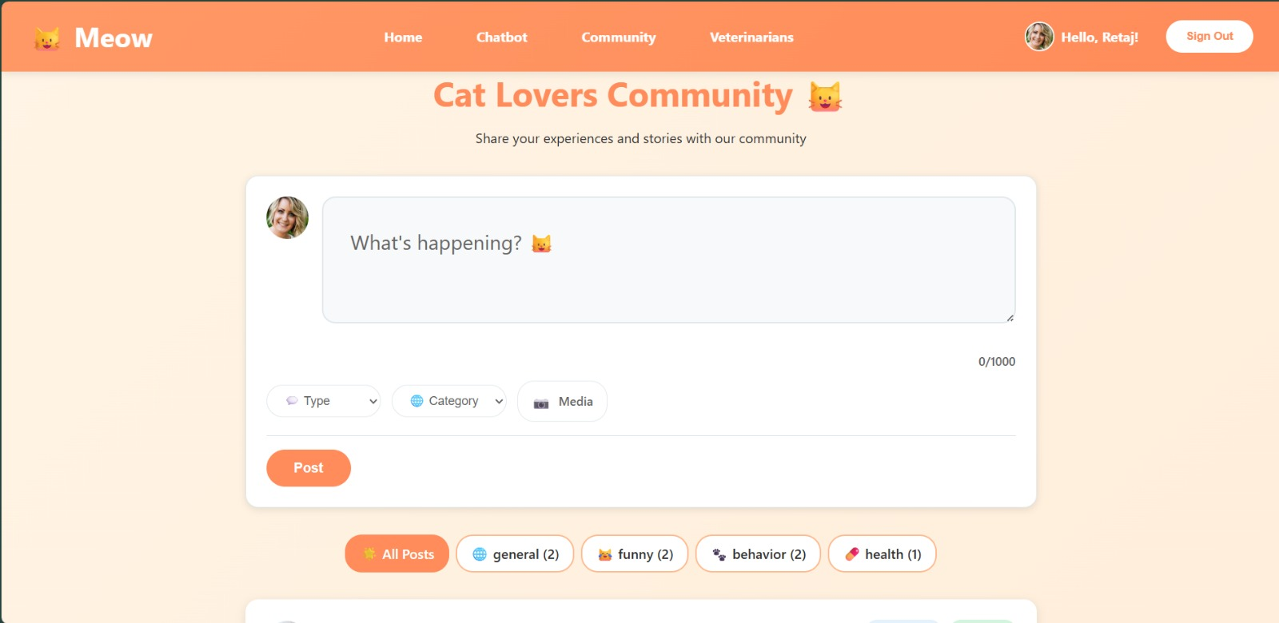
Figure1 5

Research Results and Discussions
The integration of the three systems yielded a functional and powerful solution.
- Chatbot Accuracy: When tested, the RAG chatbot consistently provided accurate, source-grounded answers to specific veterinary toxicology questions, demonstrating the effectiveness of the RAG pipeline over traditional general-purpose LLMs.
- Data Quality: The scraper module successfully retrieved structured, up-to-date data (e.g., phone numbers and ratings) for local veterinary clinics, which is crucial for the platform's utility.
- User Experience: The platform's authentication and posting features were fully operational, creating a seamless environment for community interaction. The integration of the distinct components into one ecosystem was successful, validating the architectural design.

Conclusions and Future Work
The project successfully developed an integrated platform, Meow – Cat – Community, combining a social forum, an expert RAG chatbot, and a web data scraper. The Flask backend provided the necessary glue to hold these disparate technologies together.
Future Work
- Full Integration of Scraper Data: Integrate the scraper output into the main platform's PostgreSQL database to allow users to search and view clinic locations on an interactive map.
- Expanded RAG Knowledge: Expand the chatbot’s knowledge base with additional verified veterinary research papers and local animal welfare guidelines.
- Advanced Community Features: Implement features such as private messaging, dedicated interest groups, or a pet adoption section.

References
1. AI and Retrieval References (RAG Chatbot)
Reference | Project Use
Lewis, P., Perez, E., Bonnet, E., Yang, Y., Ge, M., Chen, K., ... & Goyal, G. (2020). Retrieval-Augmented Generation for Knowledge-Intensive NLP Tasks. In Proceedings of the 33rd International Conference on Neural Information Processing Systems (NeurIPS), 33, 9459-9474. | The core reference explaining the RAG architecture used by the chatbot.
LangChain. (n.d.). LangChain Documentation. Retrieved [Insert Month, Year], from [Insert official LangChain Documentation Link]. | Reference for the orchestration library used in building the chatbot.
Jeff, J., Dau, M., Mazelier, A., Chousos, L., & Gray, F. (2017). FAISS: A library for efficient similarity search in large datasets. Retrieved from [Insert link to Facebook AI Research report]. | Reference for the vector indexing and fast search system (FAISS) used with embeddings.

2. Web Development and Infrastructure References (Community Platform)
Reference | Project Use
Greenberg, M. (2018). Flask Web Development: Developing Web Applications with Python (2nd ed.). O'Reilly Media. | Reference for the Flask framework used in building the platform's backend.
Python Software Foundation. (n.d.). Python 3 Documentation. Retrieved [Insert Month, Year], from [Insert official Python Documentation Link]. | Reference for the core programming language used.

3. Data Collection Methodology References (Scraper Module)
Reference | Project Use
The Selenium Project. (n.d.). Selenium WebDriver Documentation. Retrieved [Insert Month, Year], from [Insert official Selenium Documentation Link]. | Reference for the automation tool used to scrape clinic data from Google Maps.
Ahmed, S., & Ali, F. (2022). Data Scraping Methodologies for Dynamic Websites: A WebDriver Case Study. [Insert Journal Name]. | Reference to ground the scraping methodology (if a specific paper was used).

4. Specialized Knowledge Source Reference (Chatbot Database)
Reference | Project Use
Beasley, C. H. (2018). Clinical Veterinary Toxicology. CRC Press. | (Example): Reference for the specialized book or document that was provided as data to the RAG Chatbot.

